Vision North Somerset

Newsletter
Registered Charity 1165364 June 19

Lottery Launch Open Day
Wednesday 12th June
11am to 3pm
Come and join us and meet our three new members of staff.

Jo Healy
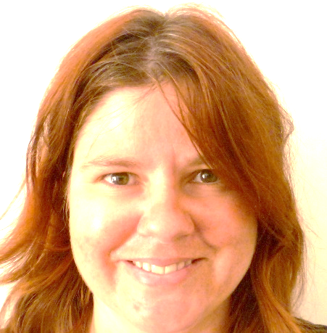
Jo Healy has more than 5 years’ experience as a Karten IT Volunteer with Vision North Somerset, helping blind and partially-sighted people to understand and use smart phones, tablets, and computers. Our National Lottery Funding means that Jo can now offer digital support to people in their own homes.

Polly Price
Polly Price has a strong background in equalities and engagement. She also has digital skills having volunteered for Vision, alongside Jo. Polly is keen to meet people who want to join in with their community and meet other people experiencing similar challenges in life.

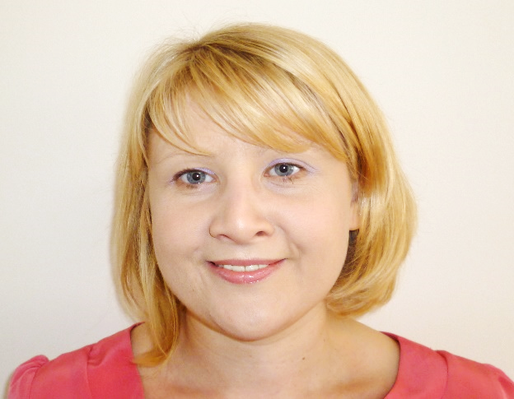
Julie Lynham
Julie Lynham joins us as our Outreach Worker. Her role is to raise awareness of the help that Vision North Somerset can offer to blind and partially sighted people and visit them at home to offer support. Julie has lots of experience of this sort of work with other local organisations.

In Sight, In Touch

Digital Outreach
‘In Sight, In Touch’ is a great opportunity for Vision North Somerset to do something different and enable our service users to really get involved. It really is all about you.
Blind and partially sighted people themselves can tell you what a difference learning how to use an iPhone has made to them. Using voice activation to call for a taxi, or contact friends is an obvious plus.
However, using apps especially designed for visually impaired people takes things to a new level. The Seeing AI app, reads correspondence, identifies colours and lots more. Soundscape orientation app helps you get from A to B by describing the route, and there are many more apps which promote independence.
Our Focus Group told us one of the barriers to learning was not being able to get to our premises in Neva Road to work with our one to one digital tutors. Our lottery funding has removed this barrier by enabling Jo to come to you. Come along to the Open Day and have a chat with Jo about options to suit you.

Connect ME
Polly is looking forward to hearing your views on the Connect ME project. This project really is all about you. Our Focus Group told us they were lonely and isolated and they wanted to be in touch with other people in a similar situation. So rather than us set up something FOR you, Polly wants you to tell her what you want, how you would like to be involved and how she can support you in getting together either on line or via face to face meetings.
The Open Day is the first opportunity for you to come along and talk to Polly, but more will follow.
Polly will also be working with Michele our Voluntary Services Coordinator to promote volunteering for blind and partially sighted people. There will be opportunities for accessible roles with Vision or externally in a field of your choice. Polly and Michele will need to know what you want to do and work with you to make it possible. We aim to remove barriers by providing awareness and guiding skills training for other groups and providing ‘buddies’ to offer one to one support for the first challenging weeks.

Outreach
For the past few years, we have lacked the capacity to go out into the community and raise awareness about our services for visually impaired people. Our lottery funding will enable Julie to visit groups, attend events and fly the flag for Vision.
Of course, once people are aware that we are here to help we need to be able to reach them as individuals. This too is part of Julie’s role and she will be able to visit people at home to tell them about the range of options available. Julie will be able to refer to colleagues here at Vision to initiate a whole range of support including information about the registration process, specialist equipment and rehabilitation.
Come along, meet Julie, and learn more about her role.

Also at our Open Day:

Human Ware
A range of hand-held or desktop electronic and digital reading aids and other assistive technology options will be available for you to try. Have a chat with Stuart to find the best solution for you.
Payment options are available.

Wiltshire Farm Foods
Samples will be available for you to try and staff are on hand to explain the ordering process and the importance of ensuring meals are nutritious as well as delicious.

Woodspring Talking News
Many of our service users are already listeners of this local talking newspaper. Have a chat with Peter and Tony to find out how they deliver local news in an accessible manner.

Dolphin Computers
Dave from Dolphin can answer your questions about software available to make computers accessible for people with sight loss, including Guide, an easy to follow system that guides you through easy steps so you can surf the web, send emails and much more.

British Wireless for the Blind
People who are registered blind or partially sighted and in receipt of certain benefits can receive a Roberts Radio free of charge from British Wireless for the Blind. A range of different sets is available so come along and try them out to find which suits you best.

Other News at Vision
Chief Executive Celia Henshall is retiring in the autumn after 25 years with the organisation. We are delighted that following a rigorous and transparent recruitment process internal candidate Nina Farr has been appointed as the new CEO and will take over in October. Many of you will know Nina in her role as Rehabilitation Officer.
Chairman Ian Parker said: “We have had a succession plan in place for some time and Nina has gradually increased her management skills as part of a career development pathway. We are pleased that an internal candidate proved to have the skills, experience and values that we need in our Chief Executive and we are delighted to welcome Nina to the post.”

A new venture for the Rendezvous Cafe
Following a successful trial involving Carry on Henry, Rendezvous Café are planning to establish a regular film session at Neva Road. The next offering will feature “Carry on up the Khyber” on Thursday 27th June, at 1.30. A charge of £1.00 includes free popcorn. So come along and enjoy the pleasure of sharing a little laughter. No need to book.

Repairs and Renewals
Whilst we are thrilled that National Lottery funding allows us to provide much needed services, we can’t forget that funds are also needed for more mundane things. We are lucky enough to own our premises – the downside is that we have to maintain and repair them too. Look out for our forthcoming appeal and how you can help.

In Memoriam
We were sad to hear that our former Chairman, Alan Griffiths passed away recently. Alan was greatly respected in the community and we thank Alan’s wife for remembering Vision for donations in lieu of flowers.
Vision North Somerset
3 Neva Road, Weston super Mare, BS23 1YD
01934 419393

